Q1.Write a program containing a possible exception. Use a try block to throw it and a catch block to handle it properly.
SOLUTION:-
PROGRAM:-
#include <iostream>
using namespace std;
int main()
{
int x = -1;
try
{
if (x < 0)
{
cout <<"Throw An Exception"<<endl;
throw x;
}
}
catch (int x )
{
cout << "Exception Was Caught"<<endl;
}
return 0;
}
OUTPUT:-
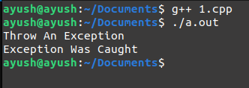

Q2.Write a program that illustrates the application of multiple catch statements.
SOLUTION:-
PROGRAM:-
#include<iostream>
using namespace std;
int main()
{
cout << "Testing multiple catches"<<endl;
int x;
cin>>x;
try
{
if (x > 0)
throw x;
else
throw 'x';
}
catch (int x)
{
cout << "Integer Caught "<<endl;
}
catch (char x)
{
cout << "Character is Caught " <<endl;
}
return 0;
}
OUPUT:-
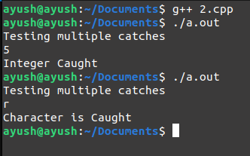

Q3.Write a program which uses catch(...) handler.
SOLUTION:-
PROGRAM:-
#include <iostream>
using namespace std;

int main()
{
try
{
throw 'x';
}
catch (int a)
{
cout << "Caught Integer "<<endl;
}
catch (...)
{
cout << "Default Exception"<<endl;
}
return 0;
}
OUTPUT:-
